**Deploy Static Web Application in us-east-1 region**

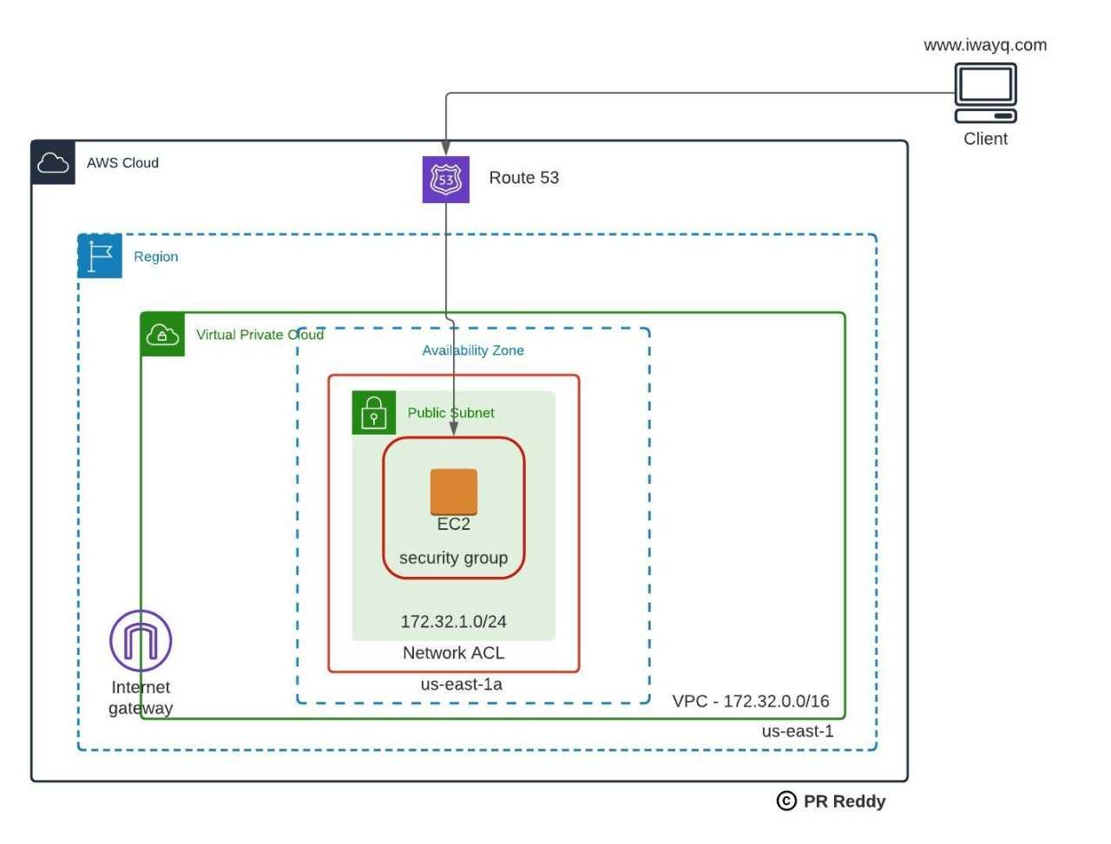

**Instructions:**

1. If you do not have domain ownership then try accessing the web application using IP address.
2. You can use Route53 or any external domain registrar to have domain resolution.

**Infrastructure Deployment:**

1. Create EC2 Instance in AWS cloud as per the architecture provided here.
2. Configurations:  
   2.1 Instance Type: t2.micro  
   2.2 AMI: ami-0be2609ba883822ec  
   2.3 Security Group:  
   Allow port 22 only from your laptop as a client.  
   Allow port 80 from anywhere  
   2.4 Network ACL:  
   Allow port 22 only from your laptop as a client.  
   Allow port 80 from Anywhere.  
   2.5 Create or attach existing keypair.  
   2.6 Default Volume of 8GB.

**Application Deployment:**

1. Login to the EC2 and install Apache Web Server
2. Deploy sample index.html file into /var/www/html directory
3. Start Apache web server.
4. Configure A record for your domain.

**Verify:**  
Verify you are able to browse the web application from your browser using the Public IP address of your EC2..